**Channel coding with incremental redundancy:**

**1) Coded Bit Error Probability:**

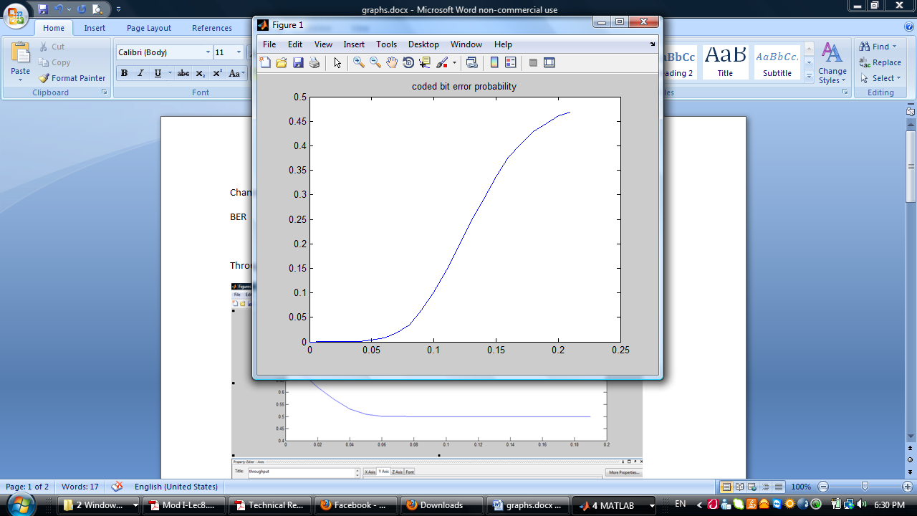

**2) Throughput:**

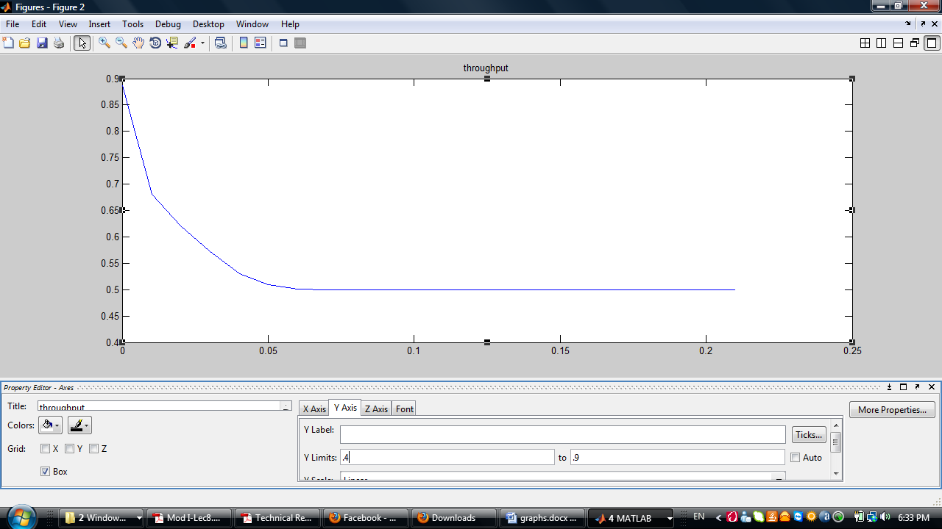

**Channel coding using rate 1/2 without incremental redundancy:**

**1) Coded Bit Error Probability:**

